


Department of Information Technology

Final Year SRS Report
Presented By: Muhammad Kamil
Roll Number: S23BINFT1M01144

Section: 7th – 3M
Super Visor: Mr. Abdul Karim Nawaz

The Islamia University of Bahawalpur, Bahawalpur

Topic of Project
Symptom Checker and Hospital Navigation System
By
Muhammad Kamil
S23BINFT1M01144
Project submitted to
Mr. Abdul Karim Nawaz
Department of Informatiom Technology,
The Islamia University of Bahawalpur.
In partial fulfillment of the requirements for the degree of

BACHELOR OF SCIENCE IN
INFORMATION TECHNOLOY (BSIT)

ABSTRACT
Healthcare access remains one of the most pressing challenges in developing countries, particularly in cities where patients often find themselves unable to determine the urgency of their medical condition or locate the most suitable healthcare facility nearby. This project addresses both of these problems through a single integrated web-based platform called the Symptom Checker and Hospital Navigation System.
The system enables users to enter their symptoms through a simple interface. Using the Gemini API for artificial intelligence-driven analysis, the system evaluates the entered symptoms and categorizes the urgency of the condition into one of three levels: immediate emergency care required, visit a doctor within twenty-four hours, or book a regular appointment at a convenient time. Once the urgency is assessed, the application presents the user with a map of nearby hospitals, clinics, and specialist centers powered by the Google Maps API, allowing them to filter results by distance, medical specialization, and availability.
Additional features include online appointment booking directly through the platform, insurance compatibility checking before visiting a facility, and a personal user dashboard where symptom history and upcoming appointments can be tracked. SMS-based appointment reminders are delivered through Twilio integration.
This document presents the Software Design Description for the Symptom Checker and Hospital Navigation System. Section 2 provides the system overview and development model adopted. Section 3 covers the system architecture including data flow, entity relationships, use cases, and class diagrams. Section 4 presents test cases and expected results. Section 5 shows the graphical user interface design of the application.

PROBLEM STATEMENT
In Pakistan, particularly in cities like Bahawalpur and Islamabad, a large portion of the population lacks access to basic healthcare guidance. When individuals experience symptoms such as chest pain, high fever, or difficulty breathing, they often do not know whether the situation requires an emergency room visit, a general physician appointment, or can be managed at home for a day or two. This uncertainty leads to two harmful outcomes. Either patients rush to emergency rooms for minor conditions, unnecessarily occupying critical medical resources, or they delay seeking care for genuinely serious conditions, risking their health and sometimes their lives.
Compounding this issue is the difficulty of finding the right medical facility. A person experiencing a cardiac symptom may not know that a specialized cardiology center is located just a few kilometers away. Directory-based searches are slow and often outdated. No single platform currently integrates symptom analysis with real-time hospital location and appointment booking for Pakistani users..

ACKNOWLEDGEMENT
I would like to express my sincere gratitude to Mr. Abdul Karim Nawaz for his continuous guidance and support throughout this project. His technical insights and constructive feedback helped shape this system into something I believe is genuinely useful. I am also thankful to the Department of Information Technology at The Islamia University of Bahawalpur for providing the academic environment and resources necessary to complete this work. Finally, I owe a great deal to my family, especially my parents, whose patience and encouragement made it possible for me to complete this project on time.

List of Figures
Figure |  |  |  |  | Figure Title |  |  |  |  |  |  |  |  |  | Page Number
Figure 2.1 |  |  |  |  | Agile Development Model Diagram |  |  |  |  |  |  |  |  |  | Page: 06
Figure 3.1 |  |  |  |  | Data Flow Diagram (Context Level) |  |  |  |  |  |  |  |  |  | Page: 10
Figure 3.2 |  |  |  |  | Entity Relationship Diagram |  |  |  |  |  |  |  |  |  | Page: 12
Figure 3.3 |  |  |  |  | Use Case Diagram |  |  |  |  |  |  |  |  |  | Page: 14
Figure 3.4 |  |  |  |  | Activity Diagram for Admin |  |  |  |  |  |  |  |  |  | Page: 16
Figure 3.5 |  |  |  |  | Activity Diagram for Patient (User) |  |  |  |  |  |  |  |  |  | Page: 17
Figure 3.6 |  |  |  |  | Sequence Diagram – Symptom Checking Flow |  |  |  |  |  |  |  |  |  | Page: 18
Figure 3.7 |  |  |  |  | Class Diagram Design |  |  |  |  |  |  |  |  |  | Page: 19

LIST OF TABLES
Table | Table Title | Page Number
Table 1.1 | Definitions, Abbreviations and Acronyms | Page: 04
Table 4.1 | Test Case – Home Page | Page: 23
Table 4.2 | Test Case – User Registration | Page: 24
Table 4.3 | Test Case – User Login | Page: 24
Table 4.4 | Test Case – Symptom Entry and Analysis | Page: 25
Table 4.5 | Test Case – Hospital Search and Filter | Page: 25
Table 4.6 | Test Case – Appointment Booking | Page: 26
Table 4.7 | Test Case – Insurance Check | Page: 26

TABLE OF CONTENTS
ABSTRACT ........................................................ I
ACKNOWLEDGEMENT ................................................. II
LIST OF FIGURES ................................................. III
LIST OF TABLES .................................................. IV

CHAPTER 1. INTRODUCTION ......................................... 02
1.1 Introduction ........................................... 02
1.2 Objectives ............................................. 03
1.3 Scope .................................................. 03
1.4 Definitions, Abbreviations and Acronyms ................ 04

CHAPTER 2. ADOPTED MODEL ........................................ 05
2.1 Agile Development Model ................................ 05
2.2 Agile Model Diagram .................................... 06
2.3 Important Features of Agile Model ...................... 06

CHAPTER 3. SYSTEM ARCHITECTURE .................................. 07
3.1 Architectural Design ................................... 07
3.2 Purpose ................................................ 08
3.3 Scope .................................................. 08
3.4 Tools and Technologies ................................. 09
3.5 Data Flow Diagram ...................................... 10
3.6 Entity Relationship Diagram ............................ 12
3.7 Use Case Diagram ....................................... 14
3.8 Activity Diagram for Admin ............................. 16
3.9 Activity Diagram for Patient (User) .................... 17
3.10 Sequence Diagram ....................................... 18
3.11 Class Diagram Design ................................... 19
3.12 Data Dictionary ........................................ 20

CHAPTER 4. TEST SPECIFICATION AND RESULTS ....................... 23

REFERENCES ...................................................... 36

CHAPTER 1: INTRODUCTION

1.1 Introduction
This document presents the Software Design Description for the Symptom Checker and Hospital Navigation System, a web-based healthcare application developed as a Final Year Project by Muhammad Kamil at the Department of Information Technology, The Islamia University of Bahawalpur.
The application is designed to help ordinary people deal with two very specific problems: not knowing how serious their symptoms are, and not being able to quickly find the right hospital or clinic nearby. The system uses artificial intelligence to analyze symptoms entered by the user and categorizes the level of medical urgency, then immediately follows this up by showing relevant healthcare facilities on an interactive map. Users can also book appointments, verify insurance acceptance, and maintain a personal record of their health history within the application.
This Software Design Description document explains the complete design of the system in sufficient detail to guide software development. The system is built using a modern web development stack consisting of React.js, Node.js, Express.js, and MongoDB on the backend, with Google Maps API for location services, Gemini API for AI-based symptom analysis, and Twilio for SMS-based appointment reminders.

1.2 Objectives
The core objectives of this system are as follows:
- To provide users with an intelligent, AI-powered tool that helps them understand the urgency of their symptoms and guides them on what medical action to take.
- To connect users with nearby hospitals, clinics, and specialist centers through an interactive map, with filters for distance, availability, and medical specialization.
- To allow users to book medical appointments online without needing to call hospitals or visit in person.
- To enable users to verify whether their health insurance is accepted at a particular facility before making the trip.
- To maintain a personal health history dashboard where users can track previous symptoms and upcoming appointments.
- To send automated SMS reminders for upcoming appointments through Twilio.
- To reduce unnecessary emergency room visits by helping patients make more informed decisions about their care.

1.3 Scope
This system is a web application accessible through any standard web browser on both desktop and mobile devices. It targets individual patients and general users who want to check their symptoms and locate medical facilities. It also includes an admin panel for managing hospital and clinic listings, user accounts, and appointment records.
The workflow of the system is as follows:
- The user opens the web application and creates an account or logs in with existing credentials.
- After logging in, the user navigates to the symptom checker and enters their current symptoms.
- The system sends the symptom data to the Gemini API, which analyzes the input and returns an urgency classification along with a possible condition description.
- The system displays the urgency level to the user: emergency, semi-urgent, or routine.
- Based on the user's location, the Google Maps API displays nearby hospitals, clinics, and specialty centers on an interactive map.
- The user applies filters such as distance, specialization, and availability to narrow down their choices.
- The user checks whether their insurance plan is accepted at a chosen facility.
- The user books an appointment directly through the platform.
- An SMS reminder is sent via Twilio before the appointment.
- The user can view their full symptom history and appointment record from their personal dashboard.
- The admin logs in to manage hospital listings, appointment records, and user accounts.

1.4 Definitions, Abbreviations and Acronyms
Table 1.1 – Definitions, Abbreviations and Acronyms
Term | Description
SDD | Software Design Document
SRS | Software Requirements Specification
API | Application Programming Interface – a set of rules that allows different software programs to communicate with each other
AI | Artificial Intelligence
JWT | JSON Web Token – a compact and self-contained way for securely transmitting information between parties as a JSON object, used here for user authentication
MERN | MongoDB, Express.js, React.js, Node.js – the full stack web technology combination used in this project
DFD | Data Flow Diagram
ER | Entity Relationship
MongoDB | A NoSQL document-oriented database used to store application data
React.js | A JavaScript library for building user interfaces, developed and maintained by Meta
Node.js | A JavaScript runtime built on Chrome's V8 engine, used for running server-side code
Express.js | A minimal and flexible Node.js web application framework
Tailwind CSS | A utility-first CSS framework used for designing the user interface
Redis | An in-memory data structure store used for caching to improve application performance
Twilio | A cloud communications platform used for sending SMS appointment reminders
Gemini API | Google's large language model API used for AI-based symptom analysis
GUI | Graphical User Interface
FR | Functional Requirement
NFR | Non-Functional Requirement
OTP | One-Time Password
HTTPS | Hypertext Transfer Protocol Secure
CRUD | Create, Read, Update, Delete – the four basic operations performed on database records

CHAPTER 2: ADOPTED MODEL

2.1 Agile Development Model
The Agile development model was selected for this project because of the iterative and flexible nature of building a healthcare web application. Healthcare applications have requirements that often need revision based on feedback, and different features such as symptom analysis, hospital mapping, and appointment booking are best developed and tested independently before integration.
Agile is a software development methodology that breaks the project into small, manageable cycles called sprints, each typically lasting two to four weeks. At the end of each sprint, a working piece of software is delivered and reviewed. This allows the developer to respond to changing requirements quickly without disrupting the entire project.
In this project, the development was divided into the following sprints:
Sprint 1 covered the basic user authentication system including registration, login, JWT-based sessions, and account management using Node.js, Express.js, and MongoDB.
Sprint 2 focused on the symptom input interface and integration with the Gemini API to return urgency classifications and possible condition descriptions.
Sprint 3 covered the hospital and clinic mapping feature using the Google Maps API, including location detection, map rendering, and filter functionality.
Sprint 4 addressed the appointment booking system, insurance verification feature, and Twilio-based SMS reminders.
Sprint 5 was dedicated to the user dashboard for symptom history tracking, the admin panel, performance optimization with Redis caching, and final testing.
This incremental approach ensured that each component was functional and tested before the next one was added, reducing integration errors and improving overall software quality.

2.2 Agile Model Diagram
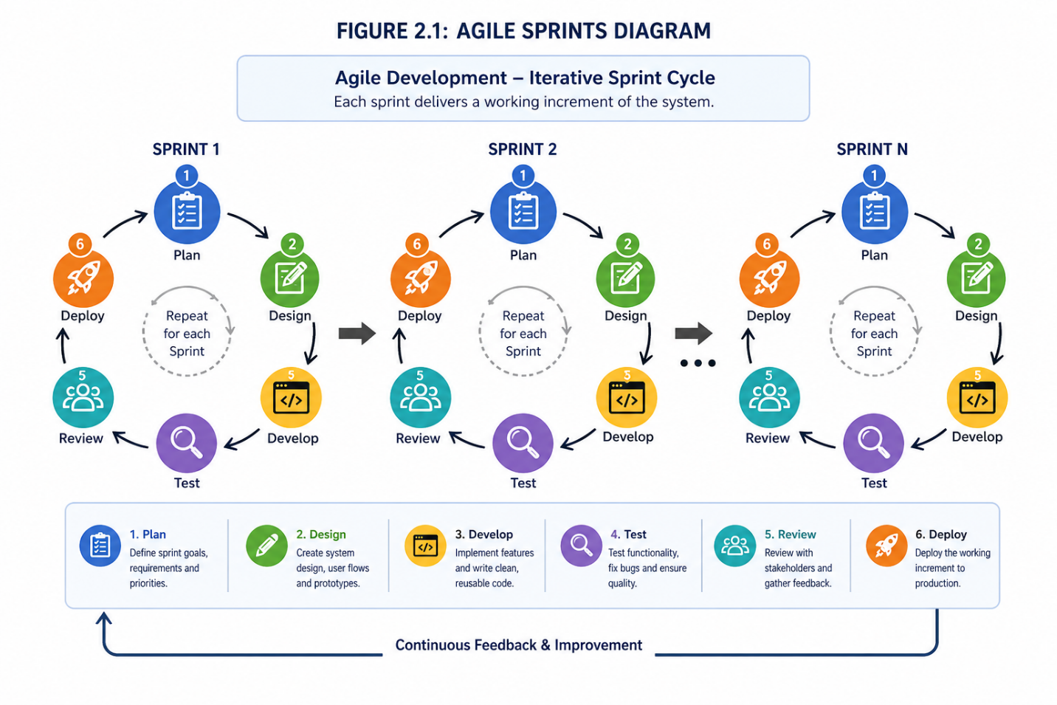

2.3 Important Features of Agile Model
- Iterative delivery: working software is produced at the end of each sprint.
- Customer collaboration: requirements are reviewed after each cycle.
- Flexibility: changes in requirements can be incorporated at any sprint boundary.
- Continuous testing: each sprint includes a testing phase before the next one begins.
- Team communication: progress is tracked through regular reviews.
- Reduced risk: because each component is tested in isolation before integration.

CHAPTER 3: SYSTEM ARCHITECTURE

3.1 Architectural Design
The Symptom Checker and Hospital Navigation System follows a client-server architecture based on the MERN stack. The frontend is a React.js single-page application that communicates with a Node.js and Express.js backend through RESTful API calls. The backend interacts with a MongoDB database to store user data, hospital records, appointment information, and symptom logs. Redis is used as an in-memory caching layer for frequently accessed data such as hospital listings, reducing the load on MongoDB and improving response times.
Three main modules make up the system:
Patient Module (User): Users can register and log in, enter symptoms, view urgency analysis results, browse hospitals on an interactive map, apply filters, check insurance, book appointments, and access their personal health dashboard.
Admin Module: The admin has access to a management panel where they can add, update, or remove hospital and clinic listings, manage user accounts, view appointment records across the platform, and review system usage analytics.
Hospital/Clinic Data Module: This module handles the stored information about healthcare facilities including their location coordinates, available specializations, operating hours, insurance plans accepted, and real-time availability status. This data is served to the Google Maps API for rendering on the frontend map.
Communication between the frontend and backend is done via HTTPS RESTful APIs. Authentication is handled using JWT tokens, which are issued at login and verified on every protected route. User passwords are hashed using bcrypt before storage. SMS reminders are dispatched asynchronously through the Twilio API to avoid blocking the main application thread.

3.2 Purpose
This document outlines the Software Design Description as part of the design plan for the Symptom Checker and Hospital Navigation System. The purpose of this document is to give a complete description of the system design in enough detail that software development can proceed with a clear understanding of what is to be built and how the components relate to each other. It covers the system architecture, data models, component interaction, test cases, and interface design.

3.3 Scope
This web application serves patients who need symptom checking guidance and hospital navigation. It also serves system administrators who manage the platform's hospital data and user records. The system does not provide formal medical diagnosis. It provides AI-assisted urgency triage based on symptom input and connects users to appropriate healthcare facilities.
The system operates entirely through a web browser with no separate client-side installation required. The backend is hosted on a cloud server and the database is managed through MongoDB Atlas. The Google Maps API requires a valid API key and active billing account. The Gemini API requires authentication through a Google Cloud project.

3.4 Tools and Technologies
React.js: Used for building the frontend user interface as a single-page application. React enables component-based development which keeps the UI modular and maintainable.
Tailwind CSS: Used for styling the frontend. Tailwind provides utility classes that allow rapid UI development without writing custom CSS from scratch.
Node.js: Used as the server-side JavaScript runtime. Node.js handles API requests, business logic, and communication between the frontend, database, and third-party APIs.
Express.js: Used as the web framework on top of Node.js. It simplifies routing, middleware management, and API endpoint creation.
MongoDB: Used as the primary database. MongoDB stores data in flexible JSON-like documents, which suits the varying structures of symptom records, hospital profiles, and appointment data.
Google Maps API: Used for rendering the interactive hospital map, detecting the user's location, calculating distances, and displaying healthcare facilities as map markers.
Gemini API: Used for AI-powered symptom analysis. The symptom text entered by the user is sent to Gemini, which returns an analysis including possible conditions and urgency level.
Redis: Used for caching frequently requested data such as hospital listings to reduce database queries and improve application response time.
JWT (JSON Web Token): Used for secure stateless authentication. After login, a token is generated and stored client-side. Every subsequent request to protected routes includes this token for verification.
Twilio: Used for sending SMS-based appointment reminders to users before their scheduled appointments.
Git / GitHub: Used for version control and project repository management.

3.5 Data Flow Diagram
The Data Flow Diagram shows how data moves between the user, the system, and external services.
Context Level DFD Description:
The external entities in this system are: Patient (User), Admin, Google Maps API, Gemini API, and Twilio.
The Patient sends symptom data and registration/login credentials to the system. The system returns urgency analysis results, hospital map data, appointment confirmations, and SMS reminders to the Patient.
The Admin sends management commands (add/update/delete hospital records, manage users) and receives system data and reports in return.
The Gemini API receives symptom queries from the system and returns AI-generated urgency analysis and possible condition descriptions.
The Google Maps API receives location coordinates and hospital data from the system and returns rendered map information and distance calculations.
Twilio receives appointment reminder requests from the system and delivers SMS messages to the patient's registered phone number.
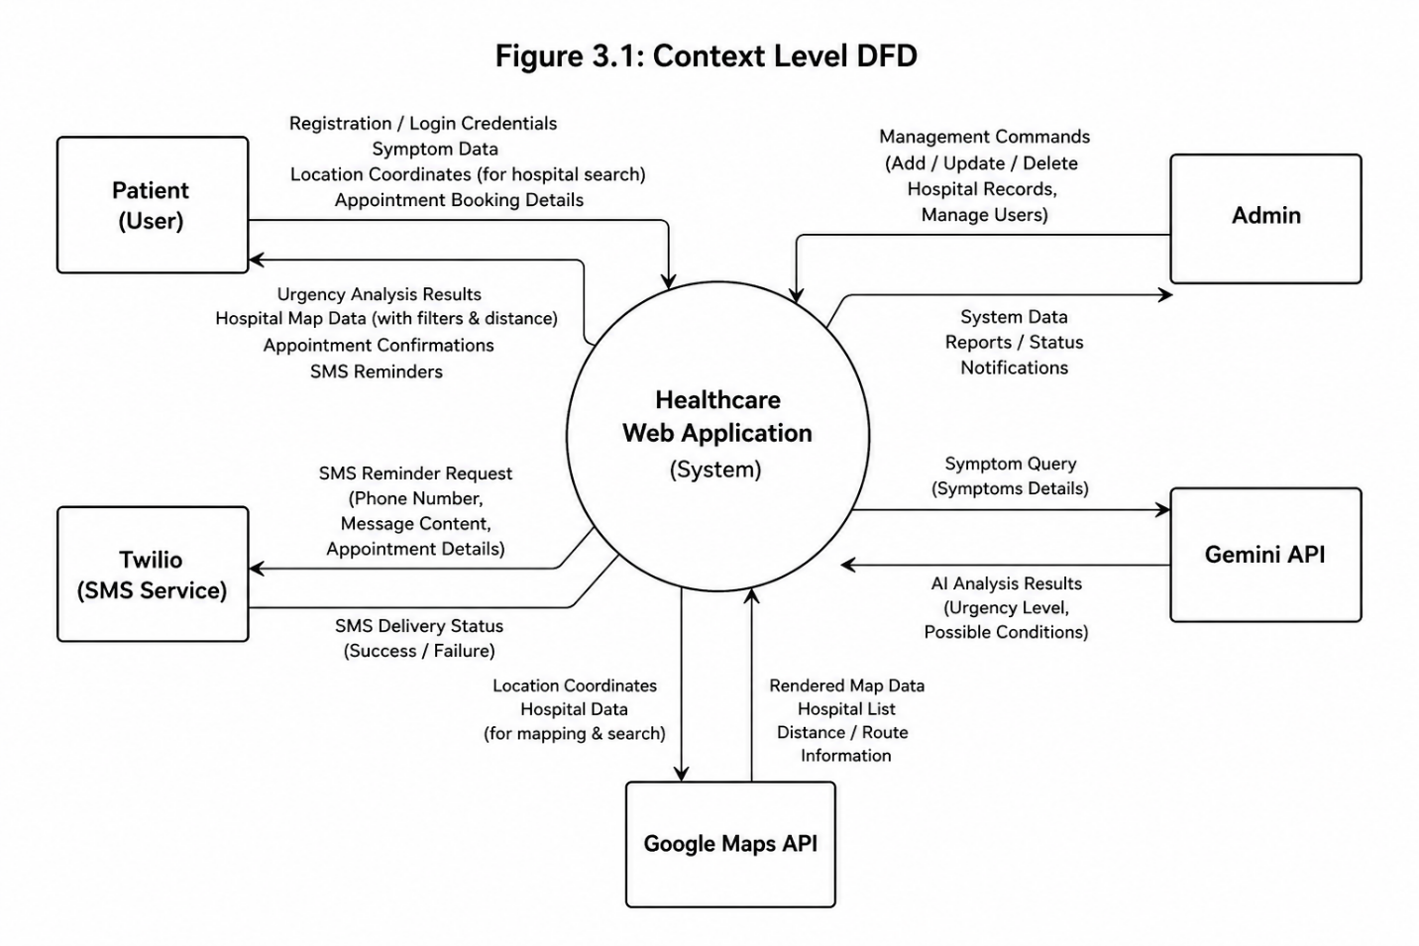

Level 1 DFD – Major Processes:
Process 1.0 – User Authentication: Accepts registration and login data from the user. Validates credentials against the Users collection in MongoDB. Issues JWT token on successful login.
Process 2.0 – Symptom Analysis: Receives symptom input from the authenticated user. Constructs a query and sends it to the Gemini API. Stores the symptom record and returned analysis in MongoDB. Returns urgency level and condition description to the user.
Process 3.0 – Hospital Search and Navigation: Retrieves the user's location. Queries the Hospitals collection (or checks Redis cache). Sends data to the Google Maps API. Returns hospital map results with filter support to the user.
Process 4.0 – Appointment Management: Receives appointment booking details from the user. Stores appointment record in MongoDB. Schedules SMS reminder via Twilio.
Process 5.0 – Admin Management: Allows admin to perform CRUD operations on hospital records and user accounts. Reads and writes to MongoDB.

3.6 Entity Relationship Diagram
The database for this system consists of the following collections in MongoDB:
User: Stores registered patient information. Fields: user_id (ObjectId, PK), full_name, email, password_hash, , phone_number, date_of_birth, insurance_provider, created_at
SymptomRecord: Stores each symptom check session for a user. Fields: record_id (ObjectId, PK), user_id (FK → User), symptoms_entered (array of strings), gemini_response (string), urgency_level (enum: emergency / semi-urgent / routine), created_at
Hospital: Stores information about hospitals and clinics. Fields: hospital_id (ObjectId, PK), name, address, latitude, longitude, specializations (array), operating_hours, insurance_accepted (array), availability_status, contact_number
Appointment: Stores appointment bookings made by users. Fields: appointment_id (ObjectId, PK), user_id (FK → User), hospital_id (FK → Hospital), appointment_date, appointment_time, status (enum: pending / confirmed / cancelled), reminder_sent (boolean), created_at
Admin: Stores admin account information. Fields: admin_id (ObjectId, PK), username, email, password_hash, role
Relationships: One User can have many SymptomRecords (1 to many). One User can have many Appointments (1 to many). One Hospital can be associated with many Appointments (1 to many). One Admin manages many Hospitals and many Users.
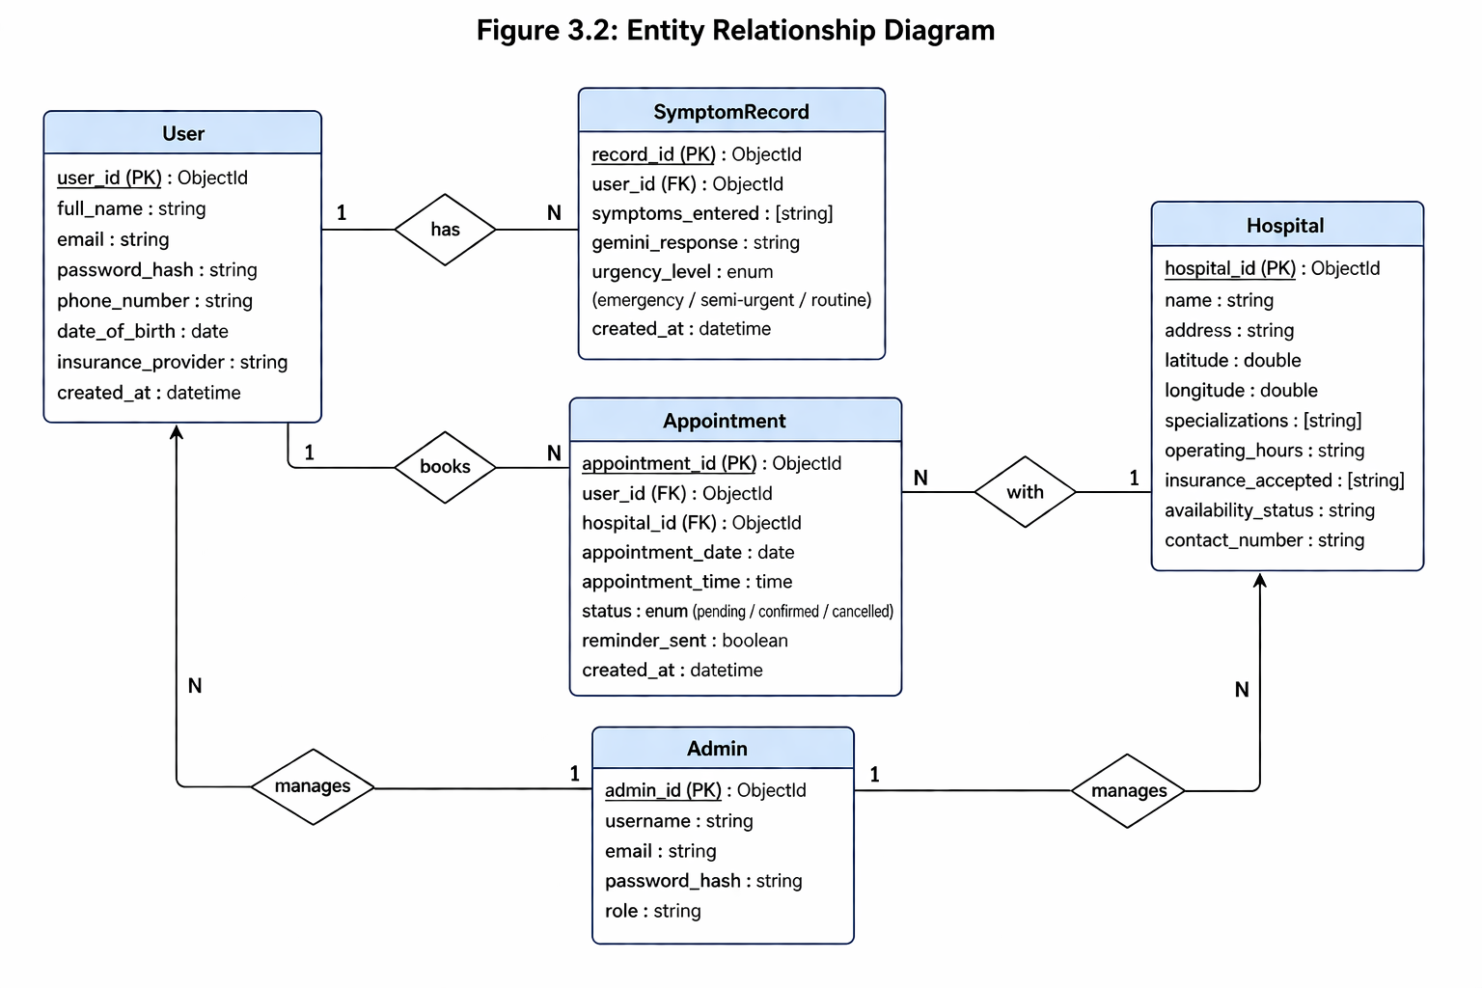

3.7 Use Case Diagram
Actors: Patient (User), Admin, Gemini API (system), Google Maps API (system), Twilio (system)
Use Cases for Patient:
- Register Account
- Login / Logout
- Enter Symptoms
- View Urgency Analysis Result
- View Hospital Map
- Filter Hospitals (by distance, specialization, availability)
- Check Insurance Acceptance
- Book Appointment
- View Symptom History
- View Upcoming Appointments

Use Cases for Admin:
- Admin Login / Logout
- Add / Update / Delete Hospital Records
- View All Users
- View All Appointments
- View System Reports
System-Level Use Cases (involving external APIs):
- Analyze Symptoms (extends Enter Symptoms → calls Gemini API)
- Display Map (extends View Hospital Map → calls Google Maps API)
- Send SMS Reminder (extends Book Appointment → calls Twilio)
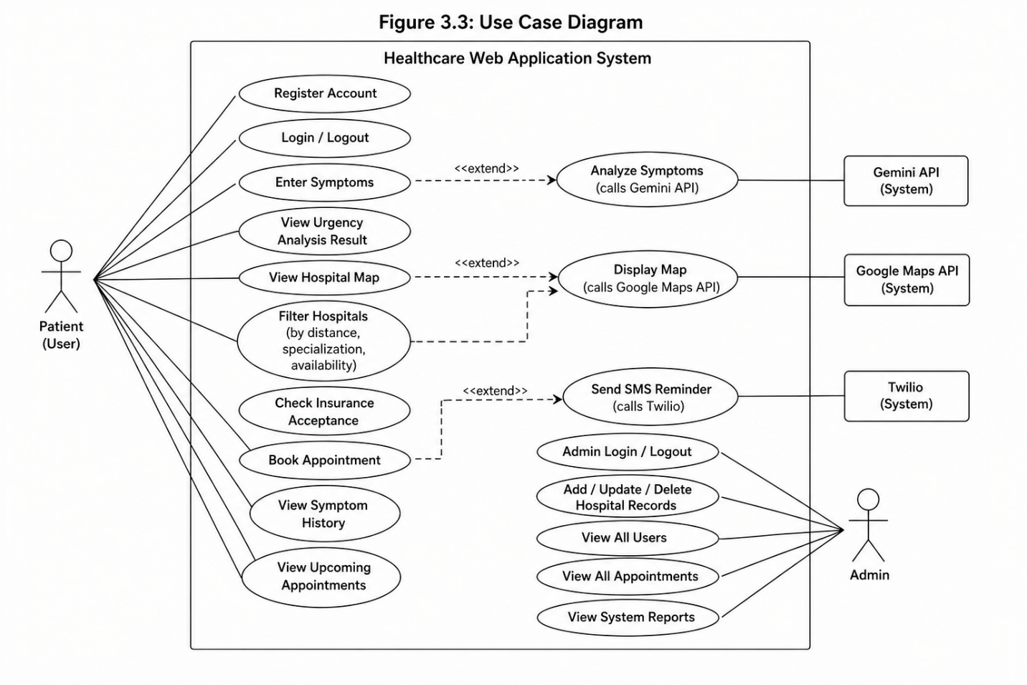

3.8 Activity Diagram for Admin
The admin activity flow begins with the admin opening the web application and entering their credentials on the admin login page. The system verifies the credentials. If authentication fails, an error message is shown and the admin is prompted to re-enter. If authentication succeeds, the admin is taken to the admin dashboard.
From the dashboard, the admin can choose one of several management actions. The admin can add a new hospital by filling in a form with all required details. The admin can update an existing hospital record by searching for it and modifying the relevant fields. The admin can deactivate or delete a hospital listing. The admin can view all registered users and their activity. The admin can view all appointments made across the platform. The admin can also view analytics and reports on system usage.
After completing the required tasks, the admin logs out and the session is terminated.
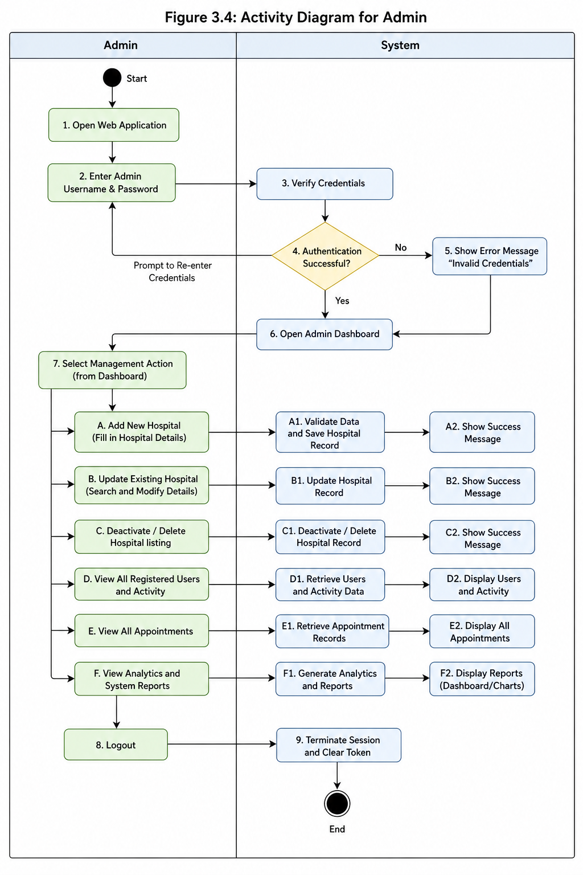

3.9 Activity Diagram for Patient (User)
The user opens the web browser and navigates to the application URL. If the user is visiting for the first time, they click on Register and fill in their name, email, phone number, password, and optional insurance information. The form is submitted and the account is created. The user then logs in with their credentials.
After login, the user is taken to the home dashboard. The user selects the Symptom Checker option and enters one or more symptoms in the input field. They submit the form. The system sends the symptoms to the Gemini API and waits for a response. The urgency level and possible condition description are displayed on the screen.
Based on the urgency result, the user navigates to the Hospital Finder. The application detects the user's location through the browser's geolocation API. Nearby hospitals are shown on the interactive Google Map. The user applies filters as needed. The user clicks on a hospital to view its details including insurance acceptance. If the user's insurance is accepted and they wish to book, they click Book Appointment and fill in the date and time. The appointment is saved and an SMS confirmation is sent via Twilio.
The user can then visit their Dashboard to view past symptom records or upcoming appointments. The user can log out when done.

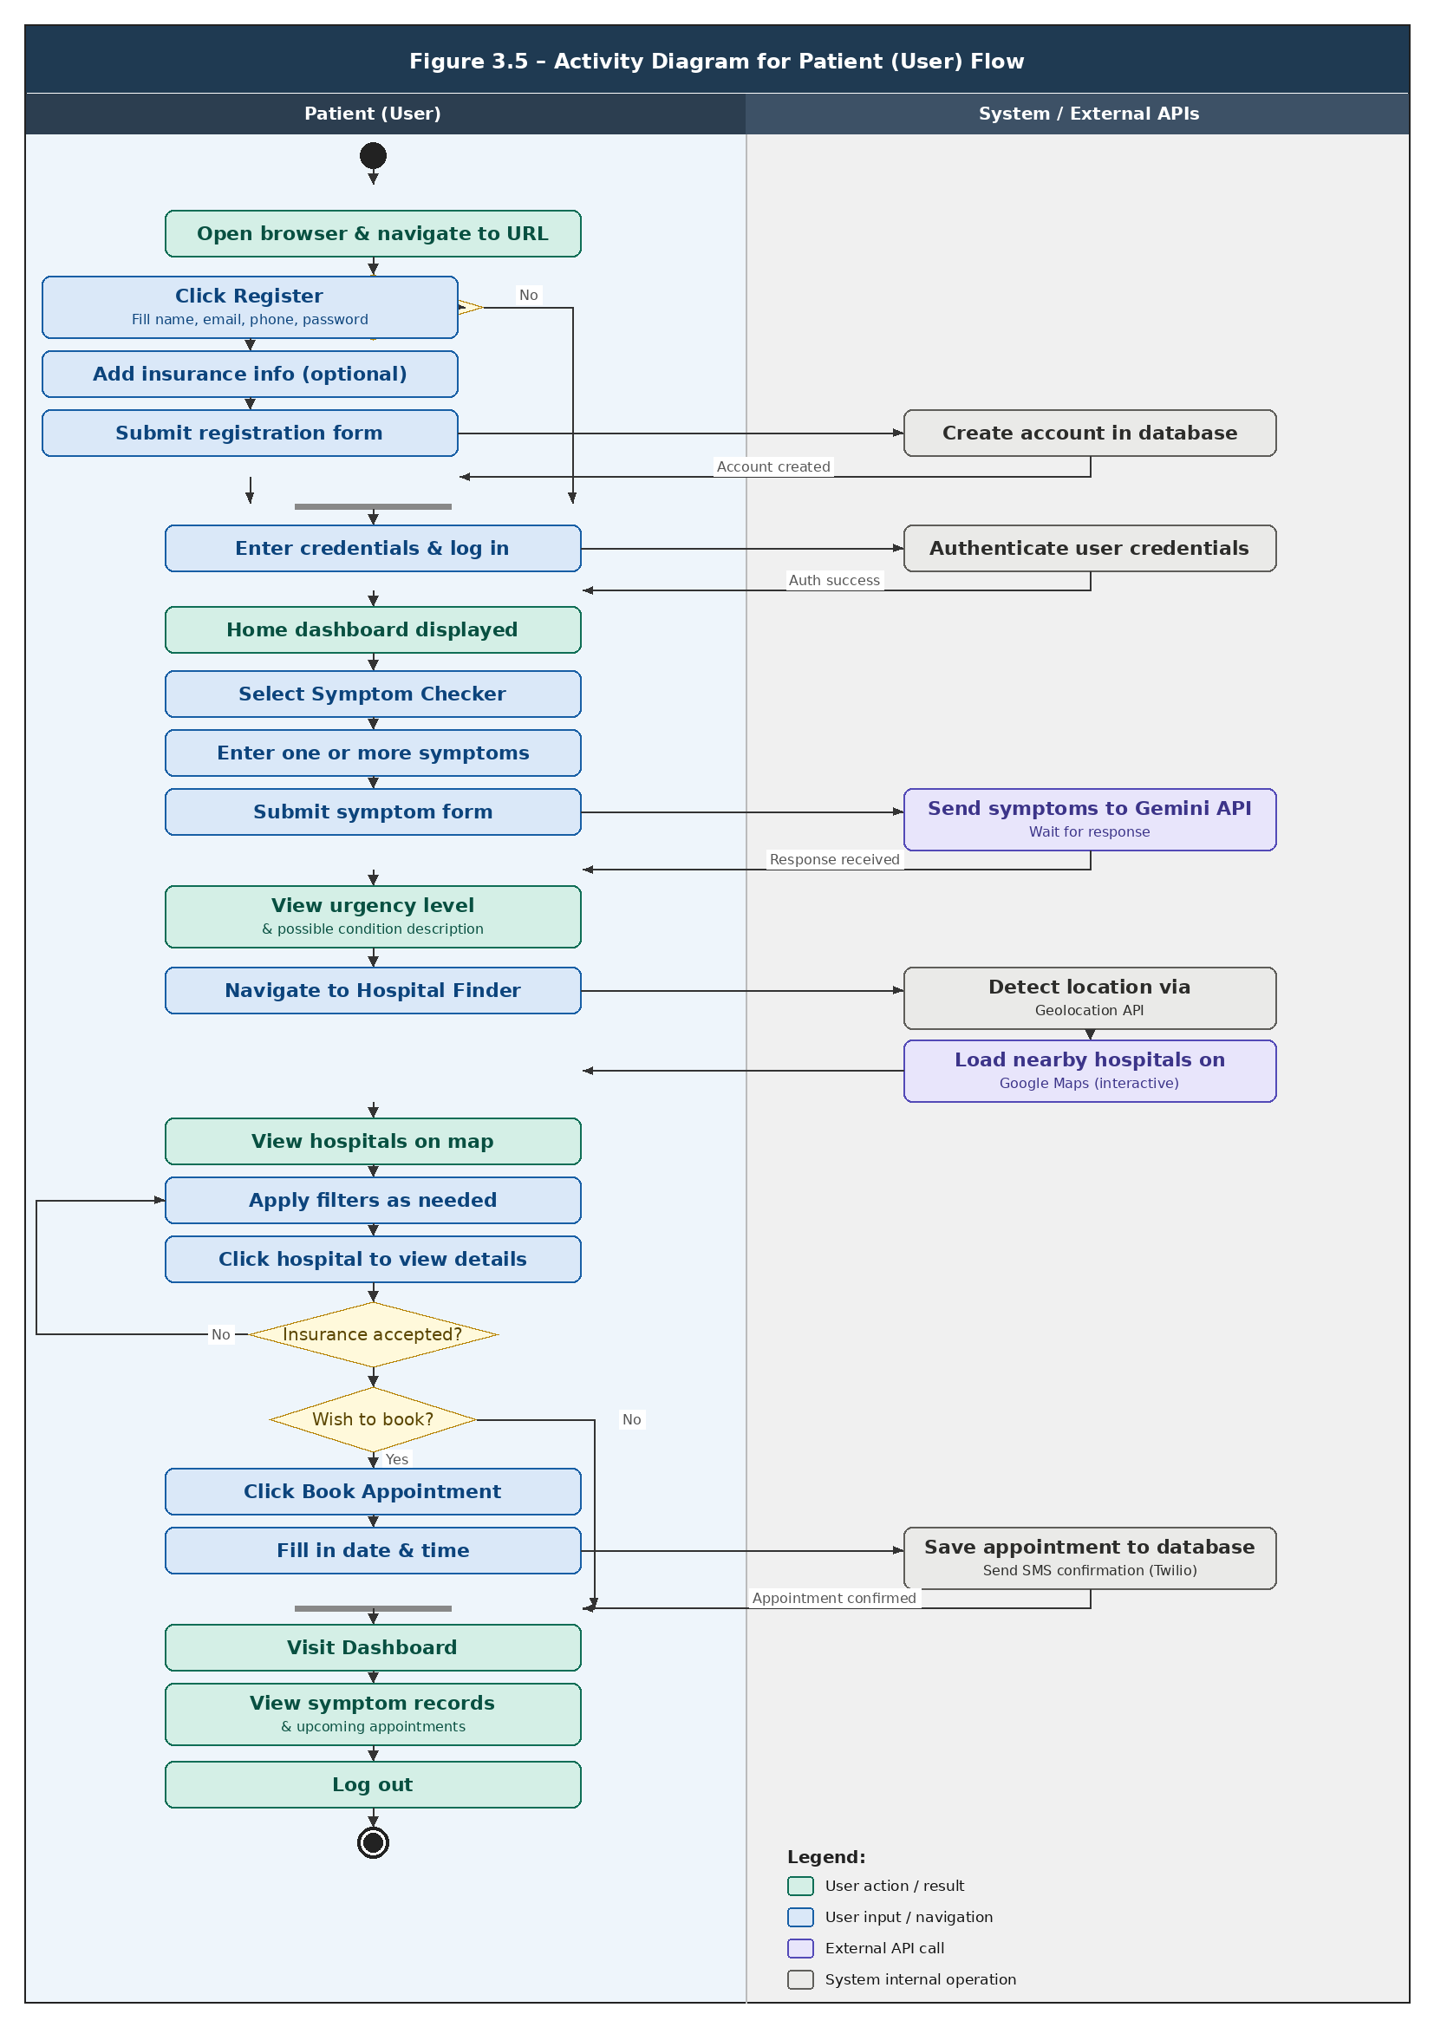

3.10 Sequence Diagram – Symptom Checking Flow
The sequence of interactions for the symptom checking feature is as follows:
- Patient opens the Symptom Checker page in the browser (React.js frontend).
- Patient enters symptoms and clicks Submit.
- React frontend sends a POST request to the Node.js/Express.js backend API endpoint /api/symptoms/analyze, including the symptom data and the JWT token in the request header.
- The backend middleware verifies the JWT token. If valid, the request proceeds.
- The backend constructs a prompt using the symptom data and sends it to the Gemini API via an HTTPS request.
- The Gemini API processes the prompt and returns a JSON response containing the urgency classification and condition description.
- The backend saves the symptom record (symptoms entered, Gemini response, urgency level, timestamp, user ID) to the SymptomRecord collection in MongoDB.
- The backend sends the analysis result back to the React frontend as a JSON response.
- The React frontend displays the urgency level and condition description to the user on the results page.
- The frontend automatically redirects or provides a button for the user to view nearby hospitals.
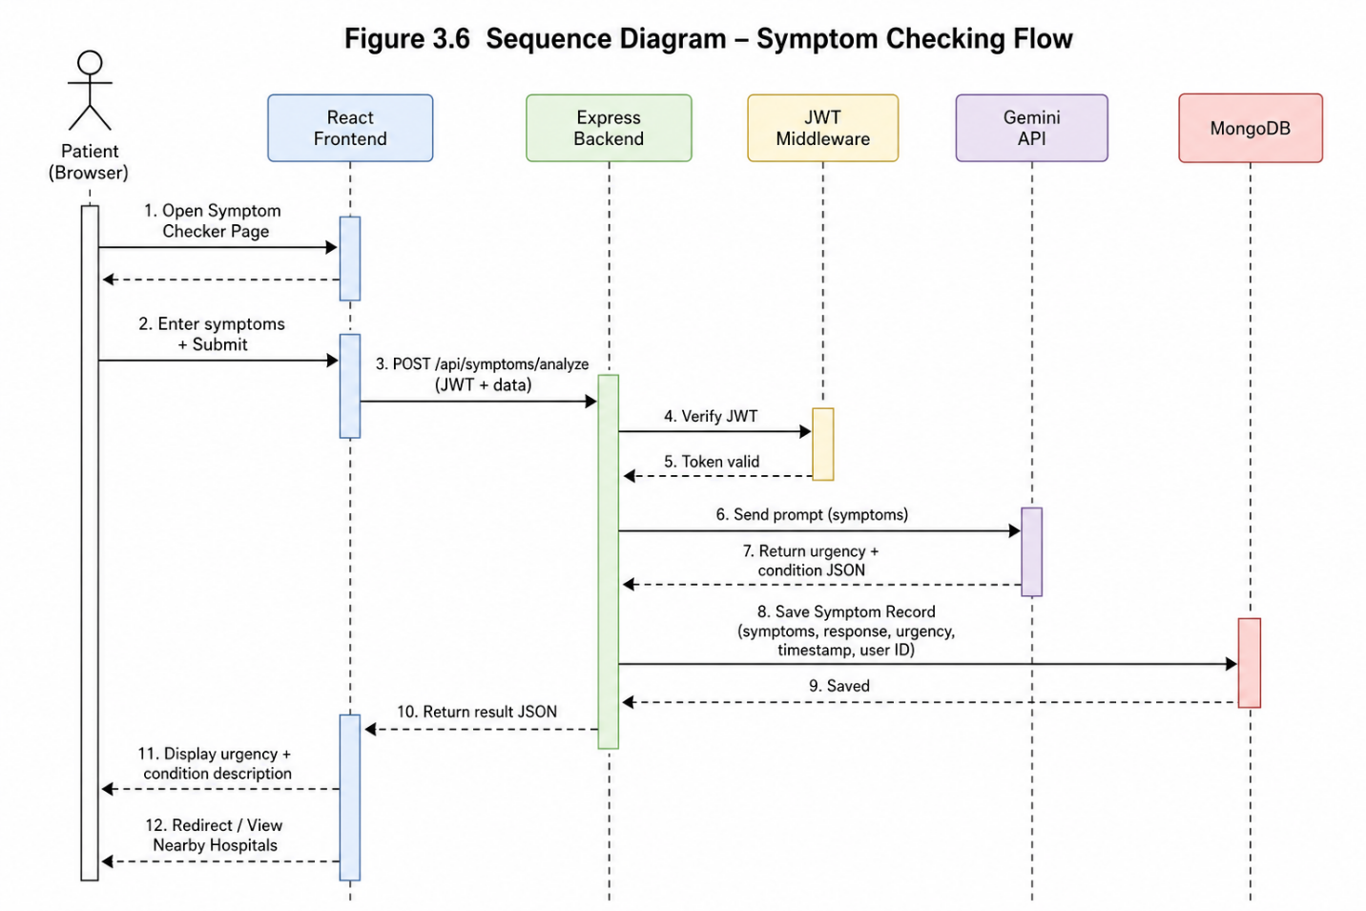

3.11 Class Diagram Design
The main classes in the system are:
User Class: Attributes: userId, fullName, email, passwordHash, phoneNumber, dateOfBirth, insuranceProvider, createdAt Methods: register(), login(), logout(), updateProfile(), viewHistory(), bookAppointment()
SymptomRecord Class: Attributes: recordId, userId, symptomsEntered[], geminiResponse, urgencyLevel, createdAt Methods: createRecord(), getRecordsByUser(), deleteRecord()
Hospital Class: Attributes: hospitalId, name, address, latitude, longitude, specializations[], operatingHours, insuranceAccepted[], availabilityStatus, contactNumber Methods: addHospital(), updateHospital(), deleteHospital(), searchByLocation(), filterBySpecialization()
Appointment Class: Attributes: appointmentId, userId, hospitalId, appointmentDate, appointmentTime, status, reminderSent, createdAt Methods: createAppointment(), cancelAppointment(), updateStatus(), sendReminder()
Admin Class: Attributes: adminId, username, email, passwordHash, role Methods: login(), logout(), manageHospitals(), manageUsers(), viewReports()
GeminiService Class (External Integration): Methods: analyzeSymptoms(symptoms): SymptomAnalysisResult
MapsService Class (External Integration): Methods: getNearbyHospitals(lat, lng, radius): Hospital[], calculateDistance(origin, destination): float
TwilioService Class (External Integration): Methods: sendSMSReminder(phoneNumber, message): boolean
Relationships: User has a one-to-many relationship with SymptomRecord. User has a one-to-many relationship with Appointment. Hospital has a one-to-many relationship with Appointment. Admin manages Hospital (aggregation, one-to-many). Appointment uses TwilioService (dependency). SymptomRecord uses GeminiService (dependency). Hospital search uses MapsService (dependency).


3.12 Data Dictionary

Users Collection
Field | Description | Data Type | Constraints
user_id | Unique system-generated identifier for each user | ObjectId | Primary Key, Auto-generated
full_name | Full name of the registered patient | String | Max 100 characters, a-z, A-Z, spaces
email | Email address used for login | String | Max 256 characters, must be unique, valid email format
password_hash | bcrypt-hashed password | String | 60 characters, system-generated hash
phone_number | Mobile number for SMS reminders | String | 11 digits, Pakistan format
date_of_birth | Patient's date of birth | Date | ISO 8601 format
insurance_provider | Name of the user's health insurance company if any | String | Max 100 characters, optional
created_at | Timestamp of account creation | Date | Auto-generated

SymptomRecord Collection
Field | Description | Data Type | Constraints
record_id | Unique identifier for each symptom check session | ObjectId | Primary Key, Auto-generated
user_id | Reference to the user who performed the check | ObjectId | Foreign Key → Users
symptoms_entered | Array of symptom strings entered by the user | Array of Strings | Max 20 items, each max 100 characters
gemini_response | Full text response returned by Gemini API | String | Max 2000 characters
urgency_level | Categorical urgency classification | Enum | Values: emergency, semi-urgent, routine
created_at | Timestamp of the symptom check | Date | Auto-generated

Hospital Collection
Field | Description | Data Type | Constraints
hospital_id | Unique identifier for each hospital or clinic | ObjectId | Primary Key, Auto-generated
name | Official name of the healthcare facility | String | Max 200 characters
address | Physical address of the facility | String | Max 300 characters
latitude | Geographic latitude coordinate | Float | Valid coordinate range
longitude | Geographic longitude coordinate | Float | Valid coordinate range
specializations | List of medical specialties offered | Array of Strings | e.g., Cardiology, Orthopedics
operating_hours | Operating hours per day | String | Formatted schedule string
insurance_accepted | List of insurance providers accepted | Array of Strings | e.g., Jubilee, EFU, Sehat Sahulat
availability_status | Whether the facility is currently active | Boolean | True / False
contact_number | Main contact number of the facility | String | Max 15 characters

Appointment Collection
Field | Description | Data Type | Constraints
appointment_id | Unique identifier for each booking | ObjectId | Primary Key, Auto-generated
user_id | Reference to the patient who booked | ObjectId | Foreign Key → Users
hospital_id | Reference to the booked hospital | ObjectId | Foreign Key → Hospitals
appointment_date | Date of the scheduled appointment | Date | Must be a future date
appointment_time | Time slot of the appointment | String | Format: HH:MM
status | Current status of the appointment | Enum | Values: pending, confirmed, cancelled
reminder_sent | Whether the SMS reminder has been sent | Boolean | Default: False
created_at | Timestamp when booking was made | Date | Auto-generated

Admin Collection
Field | Description | Data Type | Constraints
admin_id | Unique identifier for admin account | ObjectId | Primary Key, Auto-generated
username | Admin display name | String | Max 50 characters, unique
email | Admin email address | String | Max 256 characters, unique
password_hash | bcrypt-hashed admin password | String | 60 characters, system-generated
role | Admin permission level | String | Default: superadmin

CHAPTER 4: TEST SPECIFICATION AND RESULTS

Test Case 1
Test Case Title: View Home Page
Table 4.1
Field | Details
Preconditions | User must have a device with an active internet connection and a web browser (Chrome, Firefox, Edge, or Safari)
Actions | 1. Open web browser. 2. Enter the application URL. 3. Wait for the home page to load.
Expected Results | The home page loads successfully, displaying the navigation bar, symptom checker entry point, a brief description of the system, and a Login / Register button.
Tested By | Muhammad Kamil
Result | Pass

Test Case 2
Test Case Title: User Registration
Table 4.2
Field | Details
Preconditions | User must be on the home page and must not already have a registered account with the entered email.
Actions | 1. Click Register button. 2. Enter full name. 3. Enter a valid email address. 4. Enter a password (minimum 8 characters). 5. Enter a Pakistani mobile number. 6. Optionally enter insurance provider name. 7. Click Submit.
Expected Results | Account is created successfully. User is redirected to the dashboard with a welcome message.
Tested By | Muhammad Kamil
Result | Pass

Test Case 3
Test Case Title: User Login
Table 4.3
Field | Details
Preconditions | User must have a registered account.
Actions | 1. Navigate to Login page. 2. Enter registered email. 3. Enter password. 4. Click Login button.
Expected Results | User is authenticated and redirected to the personal dashboard. Invalid credentials should display an error message without revealing which field is wrong.
Tested By | Muhammad Kamil
Result | Pass

Test Case 4
Test Case Title: Symptom Entry and AI Analysis
Table 4.4
Field | Details
Preconditions | User must be logged in. Gemini API must be accessible.
Actions | 1. Navigate to Symptom Checker. 2. Enter one or more symptoms (e.g., "fever, headache, body aches"). 3. Click Analyze Symptoms.
Expected Results | The system returns an urgency level (emergency, semi-urgent, or routine) and a plain-language description of likely conditions. The result is stored in the user's symptom history.
Tested By | Muhammad Kamil
Result | Pass

Test Case 5
Test Case Title: Hospital Search and Map Filter
Table 4.5
Field | Details
Preconditions | User must be logged in. Browser must allow location access. Google Maps API must be connected.
Actions | 1. Navigate to Hospital Finder. 2. Allow location access when prompted. 3. View hospitals on the map. 4. Apply a specialization filter (e.g., "Cardiology"). 5. Apply a distance filter (e.g., within 5 km).
Expected Results | Map displays only hospitals matching the selected filters. Markers are visible on the map. Clicking a marker shows hospital name, address, contact, and specializations.
Tested By | Muhammad Kamil
Result | Pass

Test Case 6
Test Case Title: Appointment Booking
Table 4.6
Field | Details
Preconditions | User must be logged in and must have selected a hospital from the map.
Actions | 1. Click Book Appointment on the selected hospital. 2. Select a date and time slot. 3. Click Confirm Booking.
Expected Results | Appointment is saved to the database. A confirmation message appears on screen. An SMS is sent to the user's registered phone number via Twilio. The appointment appears in the user's dashboard.
Tested By | Muhammad Kamil
Result | Pass

Test Case 7
Test Case Title: Insurance Acceptance Check
Table 4.7
Field | Details
Preconditions | User must be logged in and must have entered their insurance provider during registration or profile update.
Actions | 1. Select a hospital from the map. 2. View the hospital's detail card. 3. Look for the insurance compatibility indicator.
Expected Results | If the user's insurance provider matches one in the hospital's accepted list, a green checkmark or "Insurance Accepted" label is displayed. Otherwise, a "Not Accepted" label is shown.
Tested By | Muhammad Kamil
Result | Pass

1. System Constraints (Most Important)
This tells the reader what the system cannot do or what it depends on to function. Write it as a numbered list. Examples for your project:
- The system requires an active internet connection at all times — it has no offline mode.
- The system does not provide a formal or legal medical diagnosis. It only provides AI-assisted urgency triage.
- The system only supports Pakistani mobile number formats for SMS reminders.
- The Google Maps and Gemini APIs require valid API keys and active billing accounts on Google Cloud.
- The Twilio SMS feature requires a funded Twilio account with a registered sender number.
- The system only supports web browsers — no native Android or iOS app exists.
- The admin panel is accessible only to manually created admin accounts; there is no self-registration for admins.

2. User Characteristics
Describe who your users actually are so that design and requirement decisions make sense in context. Write one paragraph per user type:
Patient / General User: Ordinary Pakistani citizens aged roughly 18 to 60, with basic smartphone literacy. They are assumed to be able to use a web browser, fill in a form, and read English or Urdu text. They are not assumed to have any medical knowledge.
System Administrator: A technically literate staff member responsible for managing hospital data and user accounts. Assumed to work on a desktop browser and have basic data management skills.

3. Assumptions and Dependencies
A short but important section. List everything your system assumes to be true and every external thing it depends on. For example:
Assumptions:
- Users will grant browser location permission for the hospital map to function.
- Users have provided a valid Pakistani mobile number during registration.
- Hospital data in the database is kept up to date by the admin.
- The Gemini API will return a structured response in the expected format.
Dependencies:
- Google Maps JavaScript API (requires active billing)
- Gemini API (requires Google Cloud project credentials)
- Twilio SMS API (requires active account and sender number)
- MongoDB Atlas (cloud database hosting)
- Node.js runtime environment on the hosting server

4. Risk Analysis
This section is rarely included by students but impresses examiners greatly. List the main risks to your project and how you handle them. A simple table works:
Risk | Likelihood | Impact | Mitigation
Gemini API returns incorrect urgency level | Medium | High | Display disclaimer that results are not medical advice
Google Maps API billing limit exceeded | Medium | High | Implement Redis caching to reduce API calls
User enters false symptoms | High | Medium | System cannot verify input; disclaimer shown on results page
Twilio SMS delivery failure | Low | Medium | Show on-screen confirmation as backup to SMS
MongoDB Atlas outage | Low | High | Application shows maintenance message gracefully

5. External Interface Requirements
You list your technologies in Section 3.4 but never formally define how each external API connects. Add a sub-section for each:
Gemini API Interface: The backend sends a POST request containing a text prompt built from the user's symptom list. The expected response is a JSON object containing an urgency classification string and a condition description string. Maximum response wait time is 5 seconds before timeout.
Google Maps API Interface: The frontend receives the user's latitude and longitude from the browser geolocation API and passes these coordinates to the Maps JavaScript API to center the map and query nearby hospital markers from the Hospitals collection.
Twilio Interface: The backend sends an SMS via Twilio's REST API using the user's stored phone number as the recipient. The message contains the hospital name, appointment date, and appointment time. This call is made asynchronously so it does not block the booking confirmation response.

6. Revision History Table
Add this at the very beginning of your document before the Abstract. It takes five minutes to write:
Version | Date | Author | Changes
1.0 | January 2025 | Muhammad Kamil | Initial draft
1.1 | February 2025 | Muhammad Kamil | Added architecture diagrams and data dictionary
1.2 | March 2025 | Muhammad Kamil | Added test cases and finalized references

Priority order if you are short on time: Write System Constraints first, then Assumptions and Dependencies, then Risk Analysis. These three together can be completed in a couple of hours and will make your SRS look complete and professional. The Revision History and External Interface Requirements are quick to add on top of those.

REFERENCES
Books:
- Sommerville, I. (2016). Software Engineering (10th ed.). Pearson Education. [Used for understanding software design documentation standards, requirements engineering, and architectural design principles.]
- Pressman, R. S., and Maxim, B. R. (2015). Software Engineering: A Practitioner's Approach (8th ed.). McGraw-Hill Education. [Used for test case design methodology and software design concepts.]
- Fowler, M. (2002). Patterns of Enterprise Application Architecture. Addison-Wesley. [Used for understanding RESTful API design and MVC architectural patterns.]
Academic Papers and Standards:
- IEEE. (1998). IEEE Recommended Practice for Software Requirements Specifications (IEEE Std 830-1998). Institute of Electrical and Electronics Engineers. Available at: https://ieeexplore.ieee.org/document/720574 [Accessed: January 2025] [Used as reference for structuring the SRS and SDD documents.]
- Rajpurkar, P., Chen, E., Banerjee, O., and Topol, E. J. (2022). AI in health and medicine. Nature Medicine, 28, 31–38. https://doi.org/10.1038/s41591-021-01614-0 [Accessed: December 2024] [Referenced for understanding AI-based symptom analysis and healthcare applications.]
- Semigran, H. L., Linder, J. A., Gidengil, C., and Mehrotra, A. (2015). Evaluation of symptom checkers for self-diagnosis and triage: audit study. BMJ, 351, h3480. https://doi.org/10.1136/bmj.h3480 [Accessed: January 2025] [Referenced for understanding limitations and design considerations of symptom checker applications.]
Official Technical Documentation:
- Meta Platforms, Inc. (2024). React – A JavaScript library for building user interfaces. https://react.dev [Accessed: February 2025] [Used for React.js component design and state management reference.]
- OpenJS Foundation. (2024). Node.js Documentation. https://nodejs.org/en/docs [Accessed: February 2025] [Used for Node.js server configuration and asynchronous programming reference.]
- MongoDB, Inc. (2024). MongoDB Documentation. https://www.mongodb.com/docs [Accessed: February 2025] [Used for database schema design, query optimization, and indexing strategies.]
- Google LLC. (2024). Google Maps Platform Documentation – Maps JavaScript API. https://developers.google.com/maps/documentation/javascript [Accessed: February 2025] [Used for implementing the interactive hospital map and geolocation features.]
- Google LLC. (2024). Gemini API Documentation. https://ai.google.dev/docs [Accessed: February 2025] [Used for integrating the Gemini API for AI-based symptom analysis.]
- Twilio Inc. (2024). Twilio SMS API Documentation. https://www.twilio.com/docs/sms [Accessed: February 2025] [Used for implementing SMS-based appointment reminder functionality.]
- Redis Ltd. (2024). Redis Documentation. https://redis.io/docs [Accessed: February 2025] [Used for caching strategy design and implementation reference.]
- Auth0 by Okta. (2024). Introduction to JSON Web Tokens. https://jwt.io/introduction [Accessed: February 2025] [Used for understanding and implementing JWT-based stateless authentication.]
Diagram and Design Tools (for creating figures in this document):
- JGraph Ltd. (2024). draw.io – Free Online Diagram Software. https://app.diagrams.net [Accessed: February 2025] [Used for creating all UML diagrams: DFD, ER Diagram, Use Case, Activity, Sequence, and Class Diagrams. Free and browser-based.]
- Lucid Software Inc. (2024). Lucidchart – Online Diagram Application. https://www.lucidchart.com [Accessed: February 2025] [Alternative tool for UML diagram creation.]

